**Farm2Store**

**A Project Report Submitted By**

|  |  |  |
| --- | --- | --- |
| **GROUP NO** | **NAME** | **ROLL NO** |
| **38** | **Lodha Dhruvil Nareshbhai** | **5020** |
| **Sadhu Chirag Amrutdas** | **5012** |

**In Partial Fulfilment For The Award Of The Degree Of**

**Bachelor Of Computer Applications**

**In**

**Collage Of Computer Application**



Navgujarat Collage Of Computer Application

**Internal Guide**

**Prof.Jhanvi Pandya**

##### 

# **ACKNOWLEDGEMENT**

#### **We Are Pleased To Present This Platform, A Revolutionary Tool Designed To Connect Farmers Directly With Retailers, Eliminating The Need For Intermediaries And Enhancing The Efficiency Of The Agricultural Supply Chain.**

# **Special Thanks To**

Farmers:

We Thank Our Farmers For Their Hard Work And Dedication To Providing Fresh Produce.

Retailers:

We Appreciate Our Shopkeepers And Retailers For Their Trust In Our Platform.

Faculty Guide:

I Would Like To Express My Special Thanks To Our Project Guide Prof. Jhanvi Pandya For Her Time And Efforts.

Her Useful Advice And Suggestion Were Really Helpful To Us During The Project Completions.

In This Aspect We Are Eternally Grateful To Her.

We Would Like To Express Our Thanks To Navgujarat Collage Of Computer Application For The Support And The Infrastructure They Have Provided, So We Could Successfully Complete The Project Documentations.

We Commit To Continuously Improving Our Platform For The Benefit Of All Users.

# **-: INDEX :-**

|  |  |  |
| --- | --- | --- |
| **S.No** | **Title** | **P.No** |
| 1 | INTRODUCTION | 4 |
| 2 | EXISTING SYSTEM | 5 |
| 3 | PROPOSED SYSTEM | 6 |
| 4 | PROJECT PROFILE | 7 |
| 5 | HARDWARE AND SOFTWARE REQUIREMENTS | 8 |
| 6 | DEVELOPMENT TOOLS AND TECHNOLOGIES | 9 |
| 7 | SYTEM FLOW DIAGRAM | 10 |
| 8 | UML DIAGRAM | 11 |
| 9 | CLASS DIAGRAM | 22 |
| 10 | ENITIY RELATIONSHIP DIAGRAM | 23 |
| 11 | DATA DICTIONARY | 24 |

# **INTRODUCTION**

**Welcome to Farm2Store**

**Bridging the Gap between Farmers and Retailers**

Our innovative online platform is designed to directly connect farmers with shopkeepers and stores, cutting out the middlemen and ensuring that every transaction is as efficient and transparent as possible.

We believe in creating a direct link between those who grow our food and those who sell it. By enabling farmers to sell their produce directly to retailers, we're not only helping farmers receive fair prices for their goods but also providing retailers with access to high-quality, fresh products.

### **How It Works**

**Sign Up**: Register as a farmer or retailer and create your profile.

**Browse & List**: Farmers list their available produce, and retailers browse through a curated selection of products.

**Connect & Negotiate**: Engage directly with potential buyers or sellers to discuss terms and finalize transactions.

**Secure Transactions**: Enjoy secure payment options and reliable delivery arrangements.

# **Existing System**

**In Existing Traditional Agriculture Trade**

**1. Limited Access to Markets:**

Small-scale farmers often struggle to access larger markets due to Inadequate infrastructure, such as poor transportation networks and lack of storage facilities. This can result in higher transportation costs and spoilage.

**2. Middlemen and Intermediaries:**

In traditional agricultural trade, multiple intermediaries may be involved between the farmer and the final consumer. Each intermediary takes a cut of the price, which can significantly reduce the share of the final price that farmers receive.

**3. Bargaining Power:**

Small-scale farmers typically have limited bargaining power compared to larger commercial buyers or traders. This imbalance often results in less favorable pricing terms for the farmers.

# **Proposed system**

#### **Connect.Trade.Thrive**

**Farm2Store** is a new era of agricultural trade, designed to bridge the gap between farmers and retailers. Our innovative online platform empowers farmers to sell their produce directly to shopkeepers and stores, eliminating intermediaries and streamlining the supply chain. By cutting out the middlemen, we help you build stronger, more direct relationships, and achieve better prices and quality.

#### **For Farmers**

**Showcase Your Produce:** List your agricultural products with detailed descriptions, high-quality photos, and pricing information to attract retailers looking for fresh, high-quality goods.

**Gain Access to New Markets:** Connect with a diverse range of retailers and stores interested in bulk purchases, expanding your reach and growing your business.

**Manage Orders Easily:** Receive and manage orders directly through our platform, with tools to track shipments and process transactions securely.

#### **For Retailers**

**Discover Fresh Products:** Browse a wide range of agricultural products directly from the source, with options to filter by type, location, and price.

**Build Strong Relationships:** Communicate directly with farmers to negotiate terms, place bulk orders, and ensure you get the best quality and value for your store.

**Streamline Your Supply Chain:** Simplify your procurement process with direct ordering, secure payments, and efficient delivery options.

# **Project Profile**

Project Title :- **Farm2Store**

Internal Guide :- Prof . Jhanvi Pandya

Project Duration :- 1-Year

Developed In :- React, Asp.Net Core

Group No :- 38

Group Member :- SADHU CHIRAG (5012)

LODHA DHRUVIL(5020)

Presented To :- Navgujarat Collage Of Computer Application

# Tools And Technology

**Fontend:**

* **Designing : HTML , CSS ,Bootstrap**
* **Technology : React**

**Backend:**

* **Technology : Asp.Net Core**
* **Database : Sql Server**

# haRDWARE & SOFTWARE REQUIREMENTS

Server-Side Hardware Requirements:

* Processor : Core i3 or higher
* RAM : 8 GB
* Hard Disk : 512 GB

Server-Side Software Requirements:

* Back-End : Asp.Net Core 8.0
* Front-End : React Js , Bootstrap
* Database : Sql Server
* Operating System : Windows 7 or Higher

Client-Side Requirements:

* Operating System : Windows 7 or Higher
* Browser : Internet Explorer 8 Or Higher, Edge, Firefox 28 or Higher, Google Chrome 34 Or Higher
* Processor : Core i3 or higher
* RAM : 8 GB
* Hard Disk : 512 GB

# **SYSTEM FLOW DIAGRAM**

# **aDMIN USE-CASE DIAGRAM**

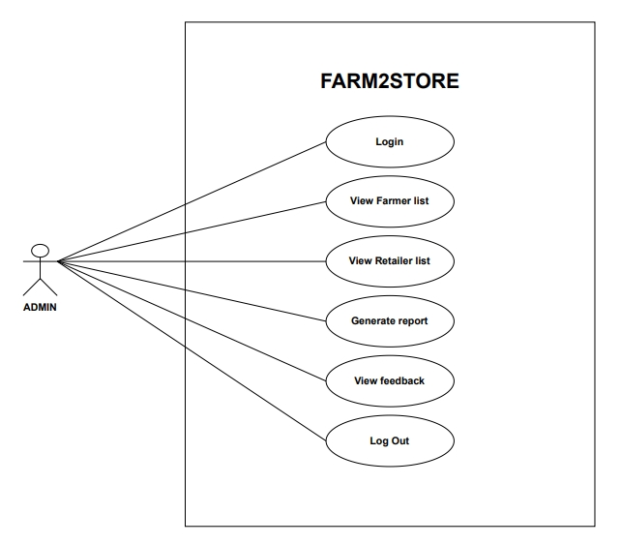

# **FARMER USE-CASE DIAGRAM**

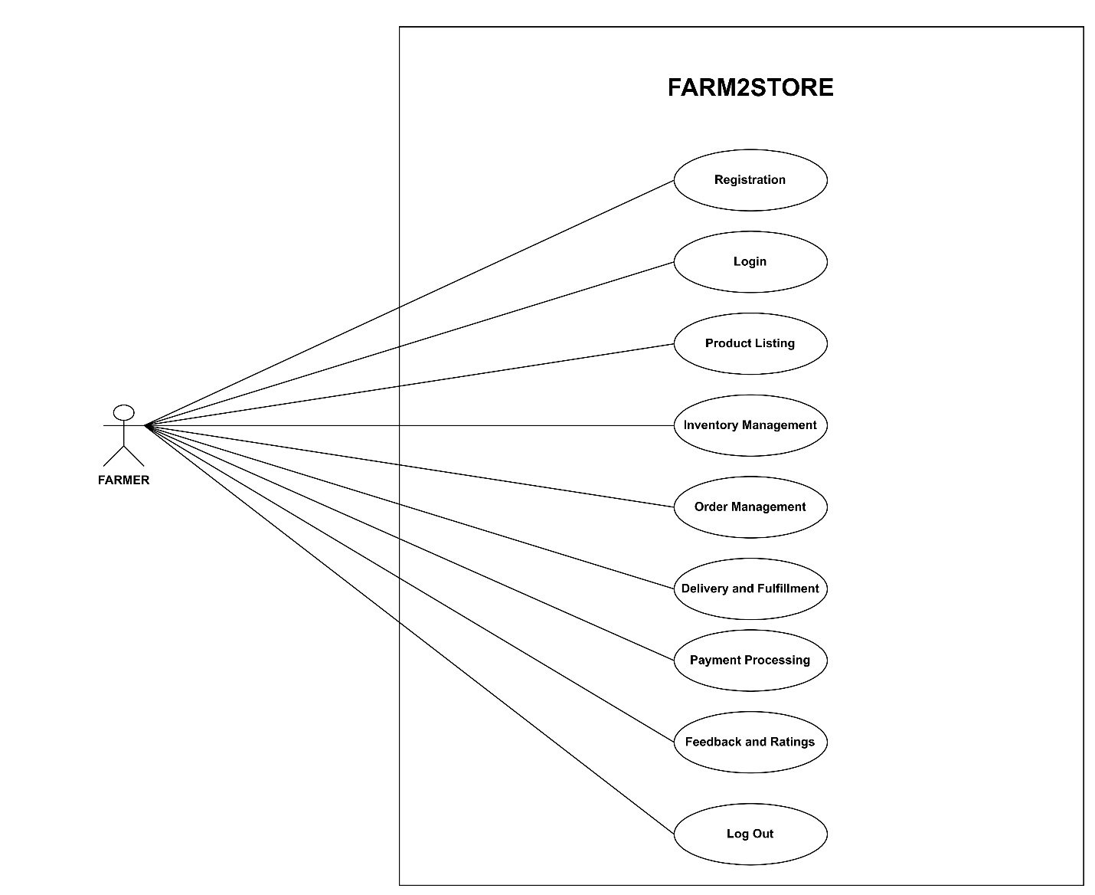

# **RETAILER USE-CASE DIAGRAM**

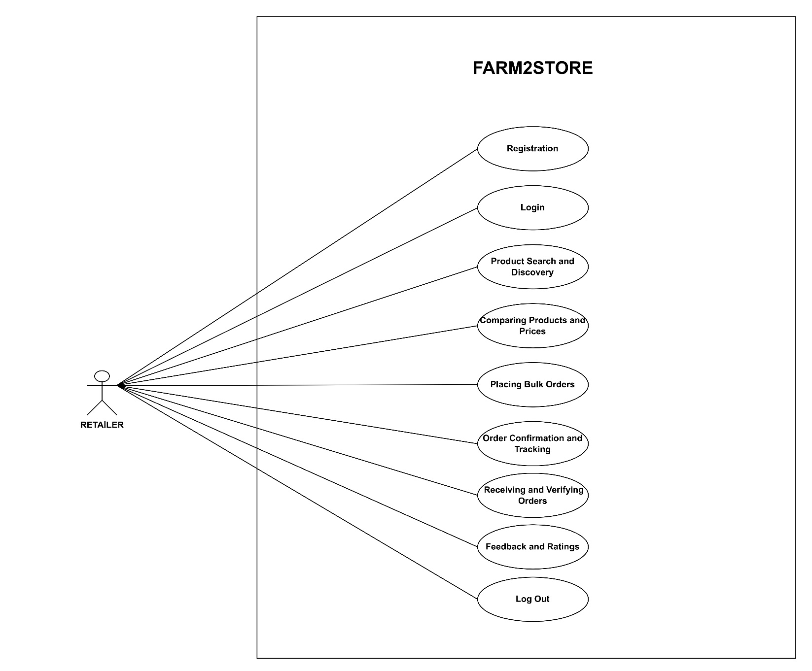

# **LOGIN SEQUENCE DIAGRAM**

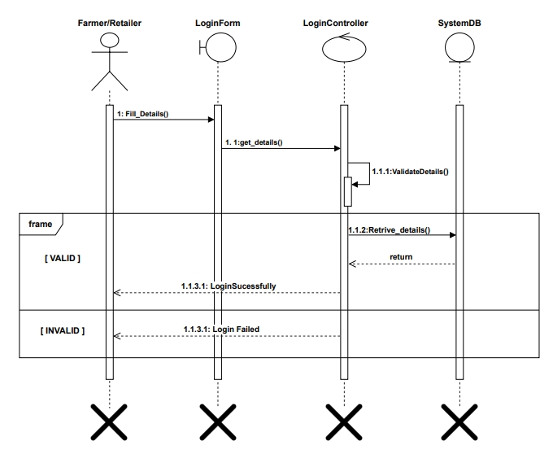

# **REGISTRATION SEQUENCE DIAGRAM**

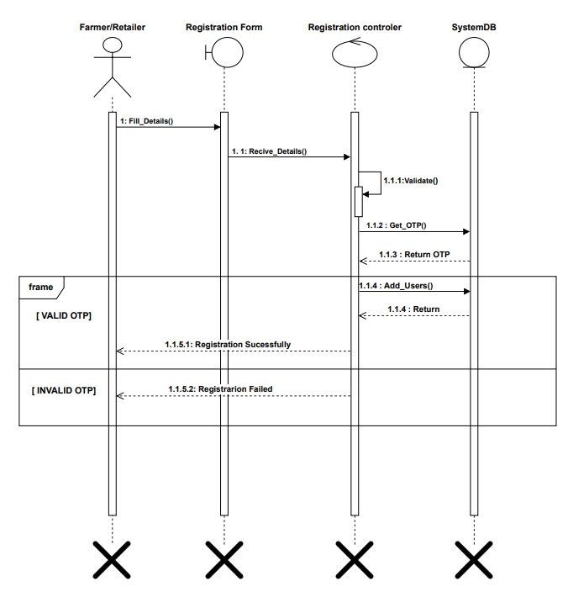

# **Manage profile SEQUENCE DIAGRAM**

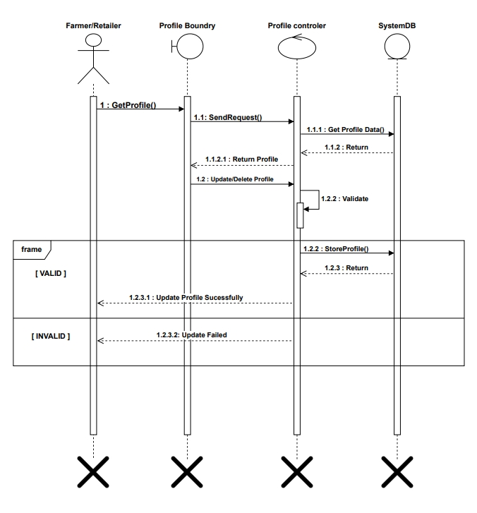

# **PAyment SEQUENCE DIAGRAM**

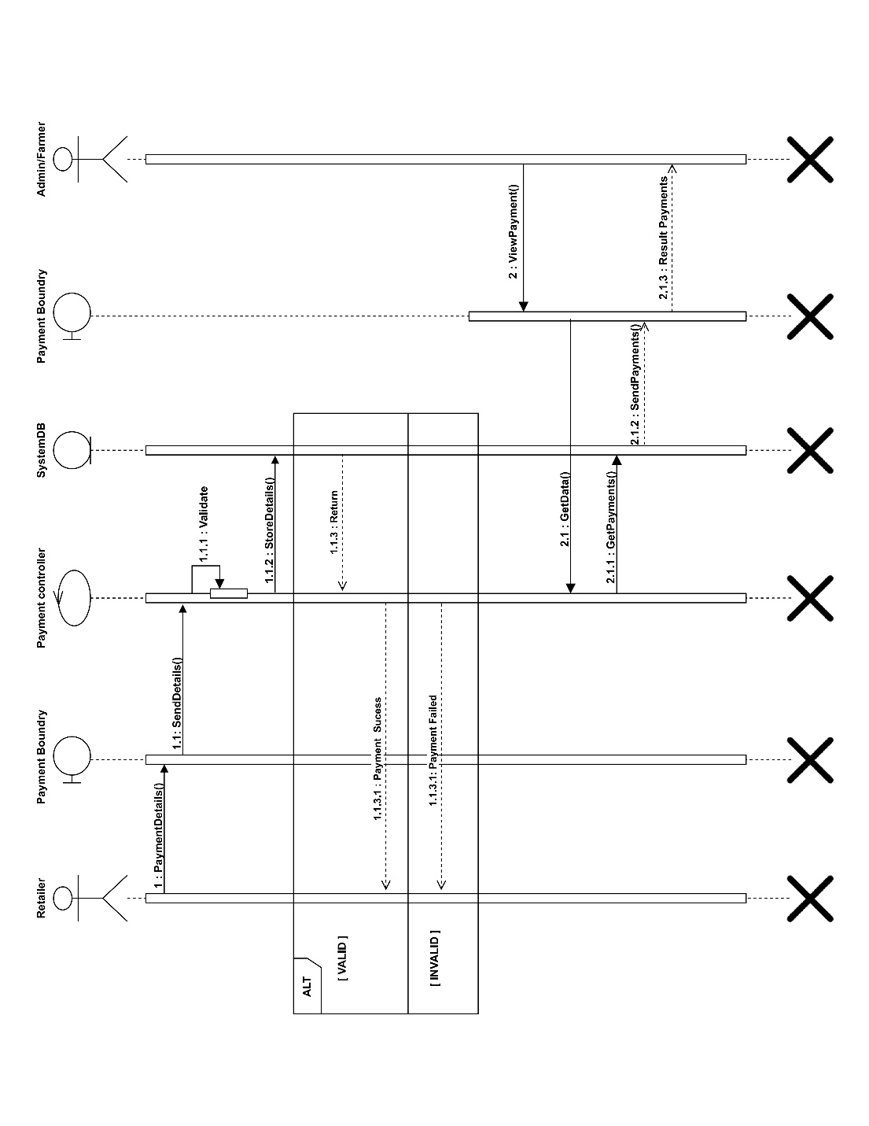

# **feedback SEQUENCE DIAGRAM**

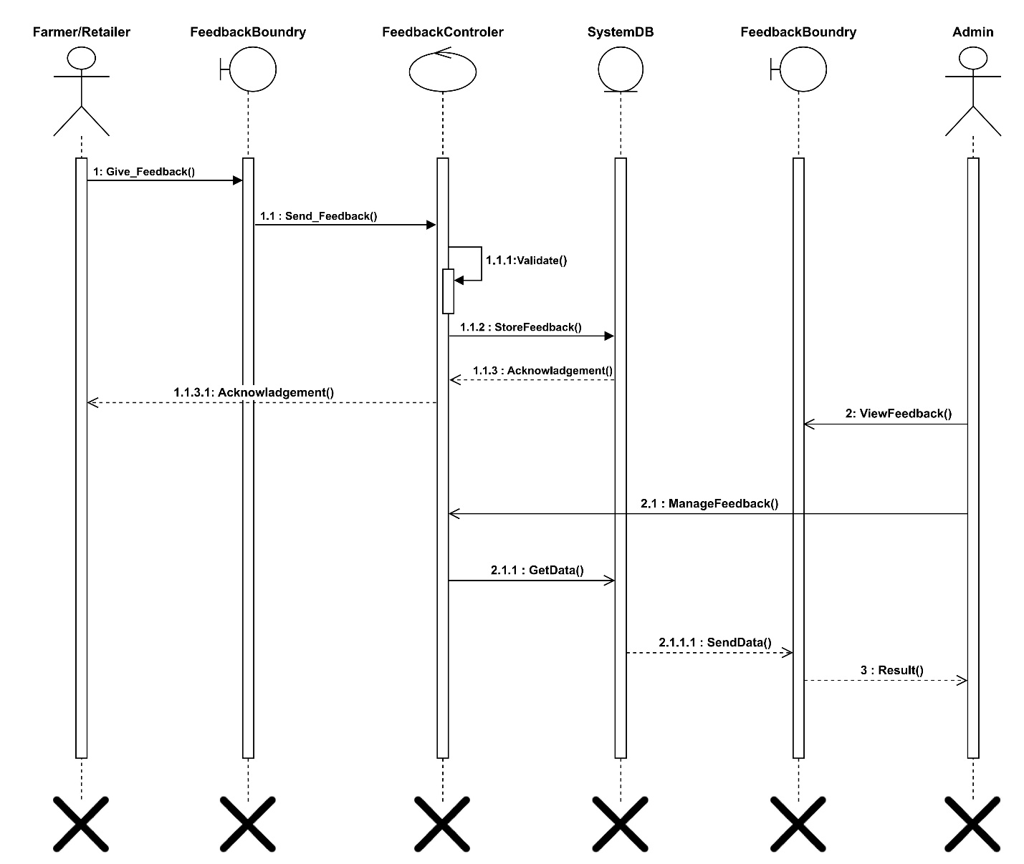

# **Placing order activity DIAGRAM**

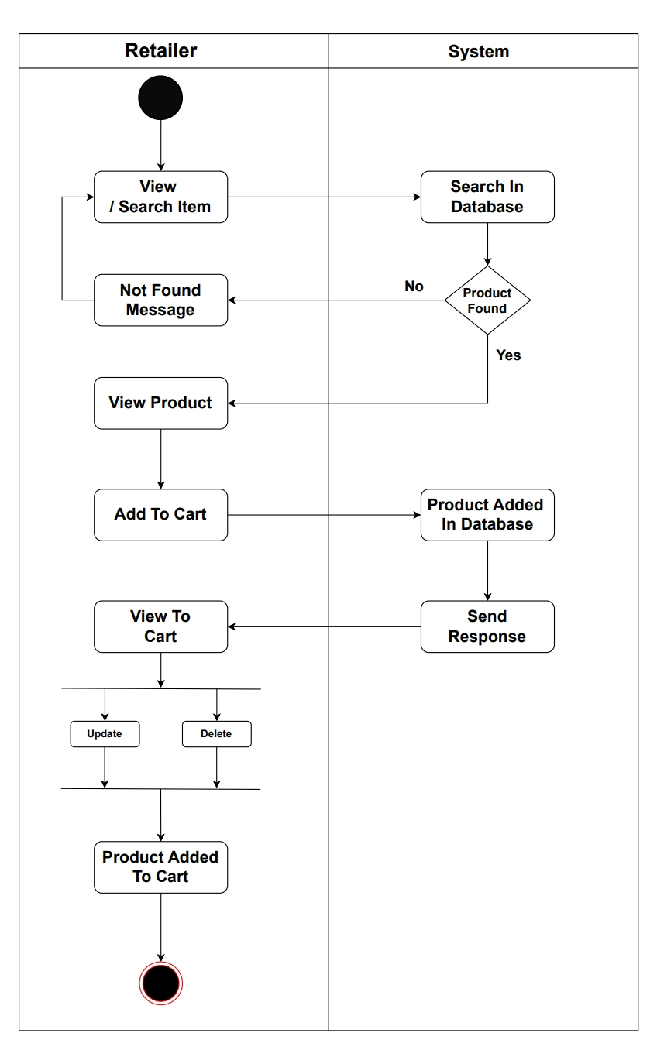

# **manage category activity DIAGRAM**

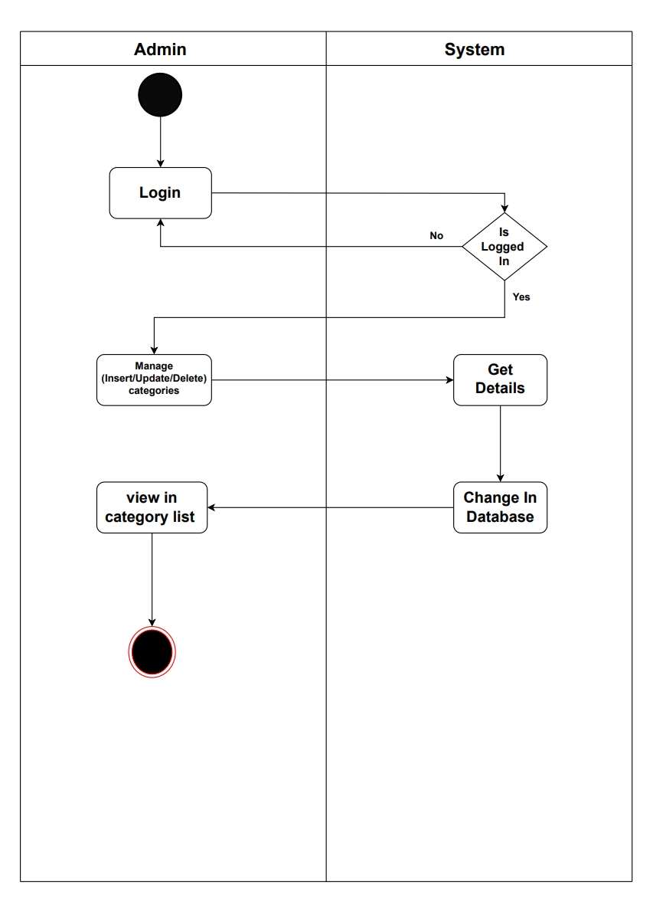

# **Manage inventory activity diagram**

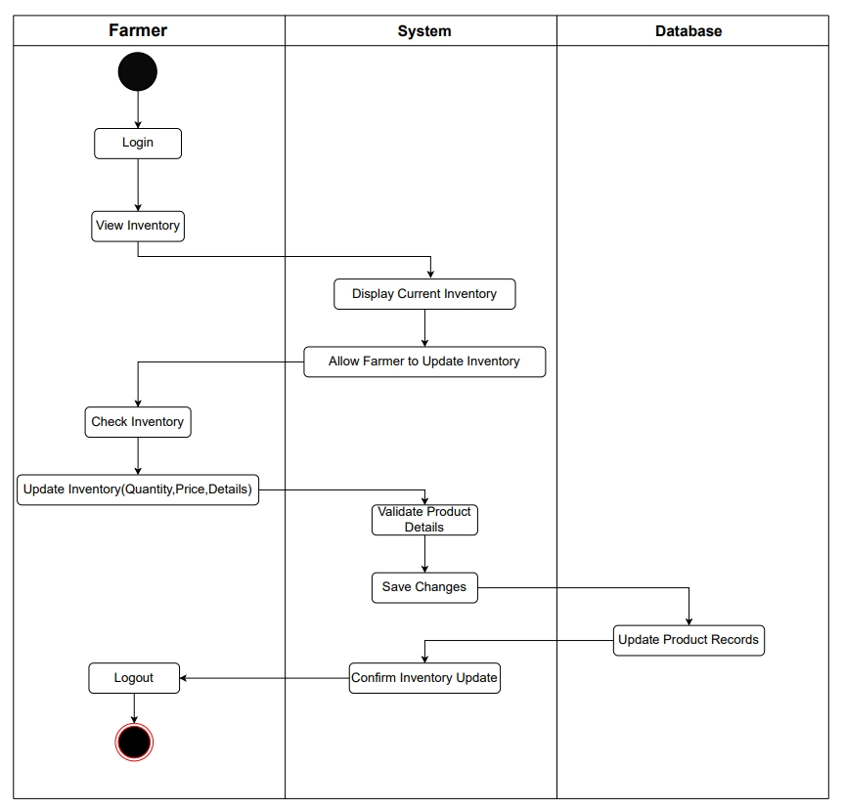

# **class DIAGRAM**

# **ER DIAGRAM**

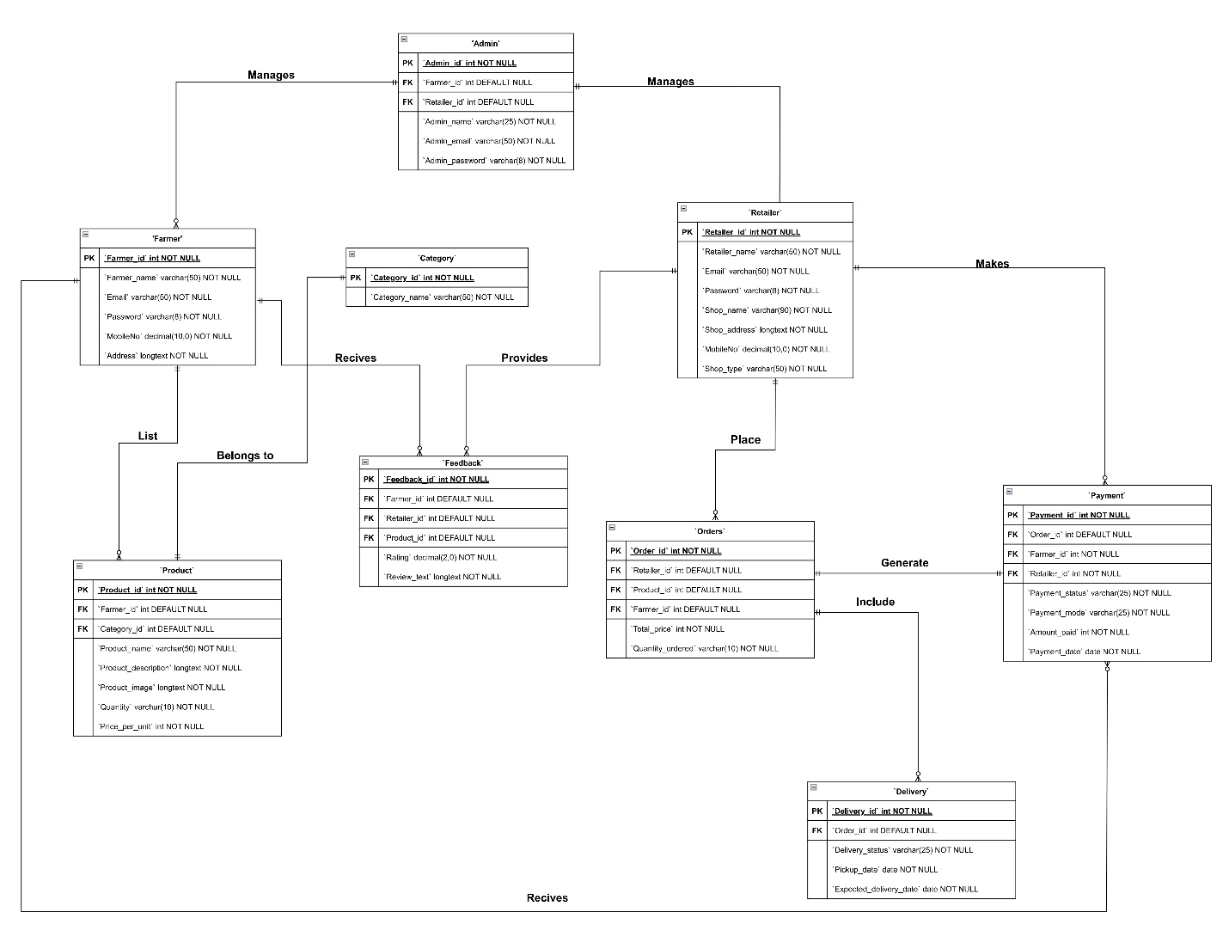

# **DATA DICTIONARY**

|  |  |  |  |  |
| --- | --- | --- | --- | --- |
| ATTRIBURE | CONSTRAIN | DATATYPE | SIZE | DESCRIPTION |
| ADMIN_ID | **PRIMARY KEY** | **INT** |  | **PRIMARY KEY FOR ADMIN TABLE, UNIQUE FOR EVERY ROW** |
| ADMIN_NAME | **NOT NULL** | **VARCHAR** | **25** | **NAME OF ADMIN** |
| ADMIN_EMAIL | **NOT NULL** | **VARCHAR** | **50** | **ADMIN EMAIL ADDRESS** |
| ADMIN_PASSWORD | **NOT NULL** | **VARCHAR** | **8** | **ADMIN PASSWORD** |
| RETAILER_ID | **FOREIGN KEY** | **INT** |  | **MAPPED WITH RETAILER TABLE** |
| FARMER_ID | **FOREIGN KEY** | **INT** |  | **MAPPED WITH FARMER TABLE** |

**1. ADMIN**

**2. FARMER**

|  |  |  |  |  |
| --- | --- | --- | --- | --- |
| ATTRIBURE | CONSTRAIN | DATATYPE | SIZE | DESCRIPTION |
| FARMER_ID | **PRIMARY KEY** | **INT** |  | **PRIMARY KEY FOR FARMER TABLE,UNIQUE FOR EVERY ROW** |
| FARMER_NAME | **NOT NULL** | **VARCHAR** | **50** | **NAME OF FARMER** |
| EMAIL | **NOT NULL** | **VARCHAR** | **50** | **FARMER EMAIL** |
| PASSWORD | **NOT NULL** | **VARCHAR** | **8** | **FARMER PASSWORD** |
| MOBILENO | **NOT NULL** | **NUMERIC** | **10** | **FARMER MOBILE NO** |
| ADDRESS | **NOT NULL** | **LONGTEXT** |  | **FARM ADDRESS** |

**3. RETAILER**

|  |  |  |  |  |
| --- | --- | --- | --- | --- |
| ATTRIBURE | CONSTRAIN | DATATYPE | SIZE | DESCRIPTION |
| RETAILER_ID | **PRIMARY KEY** | **INT** |  | **PRIMARY KEY FOR RETAILER TABLE,UNIQUE FOR EVERY ROW** |
| RETAILER_NAME | **NOT NULL** | **VARCHAR** | **50** | **NAME OF RETAILER** |
| EMAIL | **NOT NULL** | **VARCHAR** | **50** | **RETAILER EMAIL** |
| PASSWORD | **NOT NULL** | **VARCHAR** | **8** | **RETAILER PASSWORD** |
| SHOP_NAME | **NOT NULL** | **VARCHAR** | **90** | **RETAILER SHOP NAME** |
| SHOP_ADDRESS | **NOT NULL** | **LONGTEXT** |  | **RETAILER SHOP ADDRESS** |
| MOBILENO | **NOT NULL** | **NUMERIC** | **10** | **RETAILER MOBILE NO** |
| SHOP_TYPE | **NOT NULL** | **VARCHAR** | **50** | **RETAILER SHOP TYPE** |

**4. PRODUCT**

|  |  |  |  |  |
| --- | --- | --- | --- | --- |
| ATTRIBURE | CONSTRAIN | DATATYPE | SIZE | DESCRIPTION |
| PRODUCT_ID | **PRIMARY KEY** | **INT** |  | **PRIMARY KEY FOR PRODUCT TABLE,UNIQUE FOR EVERY ROW** |
| PRODUCT_NAME | **NOT NULL** | **VARCHAR** | **50** | **NAME OF PRODUCT** |
| PRODUCT_DESCRIPTION | **NOT NULL** | **LONGTEXT** |  | **DESCRIPTION OF PRODUCT** |
| PRODUCT_IMAGE | **NOT NULL** | **LONGTEXT** |  | **IMAGE OF PRODUCT** |
| QUANTITY | **NOT NULL** | **VARCHAR** | **10** | **PRODUCT OF QUANTITY** |
| PRICE_PER_UNIT | **NOT NULL** | **INT** |  | **PRICE PER UNIT OF PRODUCT** |
| FARMER_ID | **FOREIGN KEY** | **INT** |  | **MAPPED WITH FARMER TABLE** |
| CATEGORY_ID | **FOREIGN KEY** | **INT** |  | **MAPPED WITH CATEGORY TABLE** |

**5.CATEGORY**

|  |  |  |  |  |
| --- | --- | --- | --- | --- |
| ATTRIBURE | CONSTRAIN | DATATYPE | SIZE | DESCRIPTION |
| CATEGORY_ID | **PRIMARY KEY** | **INT** |  | **PRIMARY KEY FOR CATEGORY TABLE,UNIQUE FOR EVERY ROW** |
| CATEGORY_NAME | **NOT NULL** | **VARCHAR** | **50** | **NAME OF CATEGORY** |

**6. ORDERS**

|  |  |  |  |  |
| --- | --- | --- | --- | --- |
| ATTRIBURE | CONSTRAIN | DATATYPE | SIZE | DESCRIPTION |
| ORDER_ID | **PRIMARY KEY** | **INT** |  | **PRIMARY KEY FOR ORDER TABLE,UNIQUE FOR EVERY ROW** |
| QUANTITY_ORDERED | **NOT NULL** | **VARCHAR** | **10** | **OAUNTITY OF PRODUCT ORDERED** |
| TOTAL_PRICE | **NOT NULL** | **INT** |  | **TOTAL PRICE OF ORDER** |
| RETAILER_ID | **FOREIGN KEY** | **INT** |  | **MAPPED WITH RETAILER TABLE** |
| PRODUCT_ID | **FOREIGN KEY** | **INT** |  | **MAPPED WITH PRODUCT TABLE** |
| FARMER_ID | **FOREIGN KEY** | **INT** |  | **MAPPED WITH FARMER TABLE** |

**7. DELIVERY**

|  |  |  |  |  |
| --- | --- | --- | --- | --- |
| ATTRIBURE | CONSTRAIN | DATATYPE | SIZE | DESCRIPTION |
| DELIVERY_ID | **PRIMARY KEY** | **INT** |  | **PRIMARY KEY FOR DELIVERY TABLE,UNIQUE FOR EVERY ROW** |
| DELIVERY_STATUS | **NOT NULL** | **VARCHAR** | **10** | **STATUS OF DELIVERY** |
| PICKUP_DATE | **NOT NULL** | **DATE** |  | **PICKUP DATE FOR DELIVERY** |
| EXPECTED_DELIVERY_DATE | **NOT NULL** | **DATE** |  | **EXPECTED DATE FOR DELIVERY** |
| ORDER_ID | **FOREIGN KEY** | **INT** |  | **MAPPED WITH ORDER TABLE** |

**8. PAYMENT**

|  |  |  |  |  |
| --- | --- | --- | --- | --- |
| ATTRIBURE | CONSTRAIN | DATATYPE | SIZE | DESCRIPTION |
| PAYMENT_ID | **PRIMARY KEY** | **INT** |  | **PRIMARY KEY FOR PAYMENT TABLE,UNIQUE FOR EVERY ROW** |
| PAYMENT_STATUS | **NOT NULL** | **VARCHAR** | **25** | **STATUS OF PAYMENT** |
| PAYMENT_MODE | **NOT NULL** | **VARCHAR** | **25** | **MODE OF PAYMENT** |
| AMOUNT_PAID | **NOT NULL** | **INT** |  | **AMOUNT PAID FOR ORDER** |
| PAYMENT_DATE | **NOT NULL** | **DATE** |  | **DATE OF PAYMENT** |
| RETAILER_ID | **FOREIGN KEY** | **INT** |  | **MAPPED WITH RETAILER TABLE** |
| FARMER_ID | **FOREIGN KEY** | **INT** |  | **MAPPED WITH FARMER TABLE** |
| ORDER_ID | **FOREIGN KEY** | **INT** |  | **MAPPED WITH ORDER TABLE** |

**9. FEEDBACK**

|  |  |  |  |  |
| --- | --- | --- | --- | --- |
| ATTRIBURE | CONSTRAIN | DATATYPE | SIZE | DESCRIPTION |
| FEEDBACK_ID | **PRIMARY KEY** | **INT** |  | **PRIMARY KEY FOR FEEDBACK TABLE,UNIQUE FOR EVERY ROW** |
| RATING | **NOT NULL** | **INT** | **2** | **RATING FOR PRODUCT** |
| REVIEW_TEXT | **NOT NULL** | **LONGTEXT** |  | **REVIEW FOR ORDERS** |
| PRODUCT_ID | **FOREIGN KEY** | **INT** |  | **MAPPED WITH PRODUCT TABLE** |
| RETAILER_ID | **FOREIGN KEY** | **INT** |  | **MAPPED WITH RETAILER TABLE** |
| FARMER_ID | **FOREIGN KEY** | **INT** |  | **MAPPED WITH FARMER TABLE** |